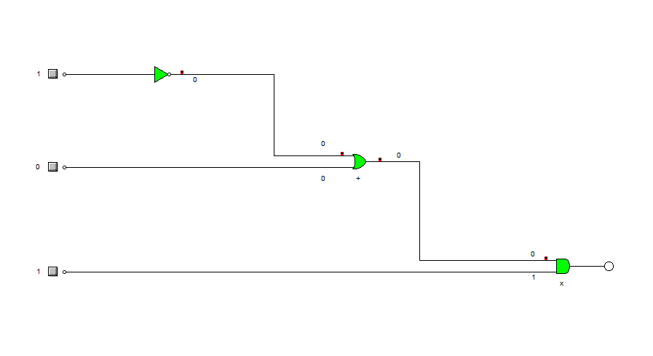
TABLAS DE VERDAD

A | B | C | salida
0 | 0 | 0 | 0
0 | 0 | 1 | 1
0 | 1 | 0 | 0
0 | 1 | 1 | 0
1 | 0 | 0 | 0
1 | 0 | 1 | 0
1 | 1 | 0 | 0
1 | 1 | 1 | 1

Salida = ( a + b ) c
Salidas = a*b*c + a*b*c
Letra = 0
Letra = 1

